EXP NO 2:
CREATE A SIMPLE CLOUD SOFTWARE APPLICATION FOR FLIGHT RESERVATION SYSTEM USING ANY CLOUD SERVICE PROVIDER TO DEMONSTRATE SAAS.
DATE:
AIM:
To create a simple cloud software application for flight reservation system using any cloud service provider to demonstrate SaaS.
PROCEDURE:
step1: Go to zoho.com. step 2: Log into the zoho.com. step 3: Select one application step.
step4: Enter application name as flight reservation system. step 5: Created new application flight reservation system.
step 6: Select one form step 7: The software has been created.
FORM DESIGN:
1.USER DETAILS
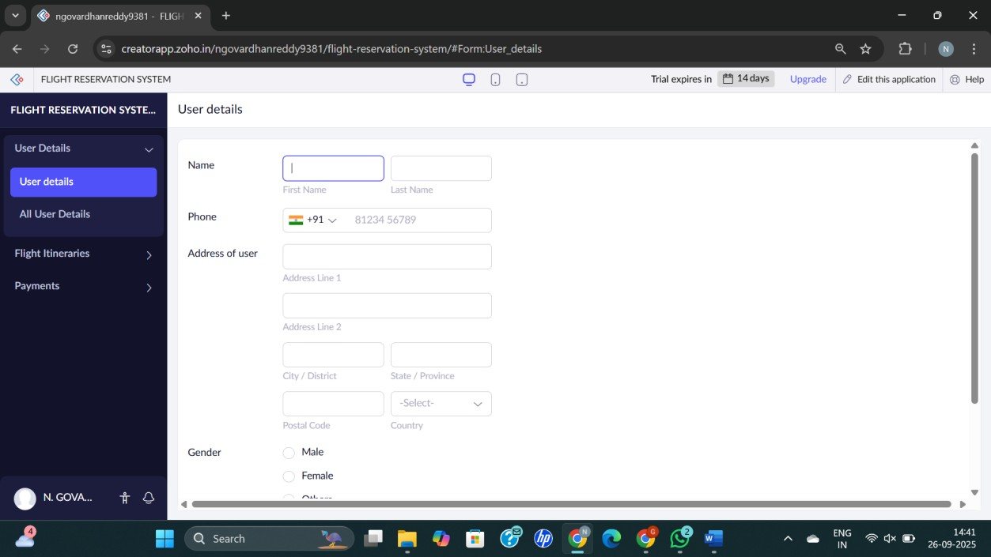
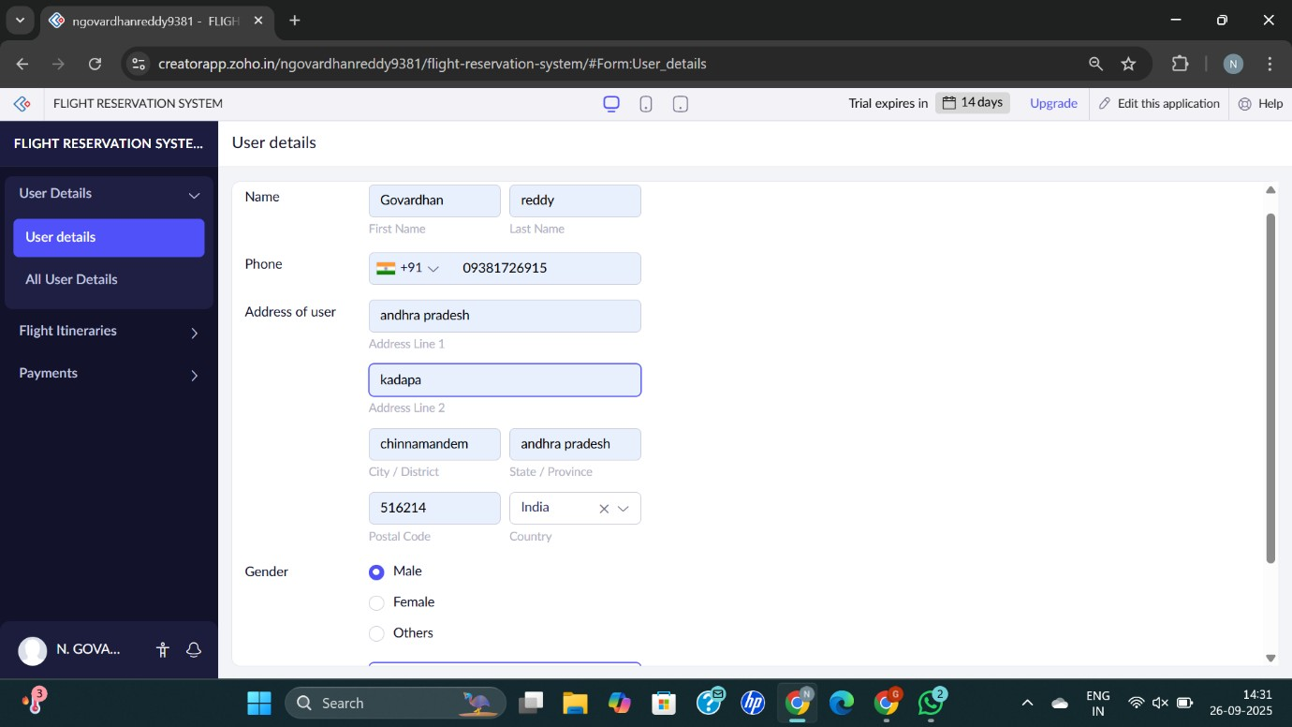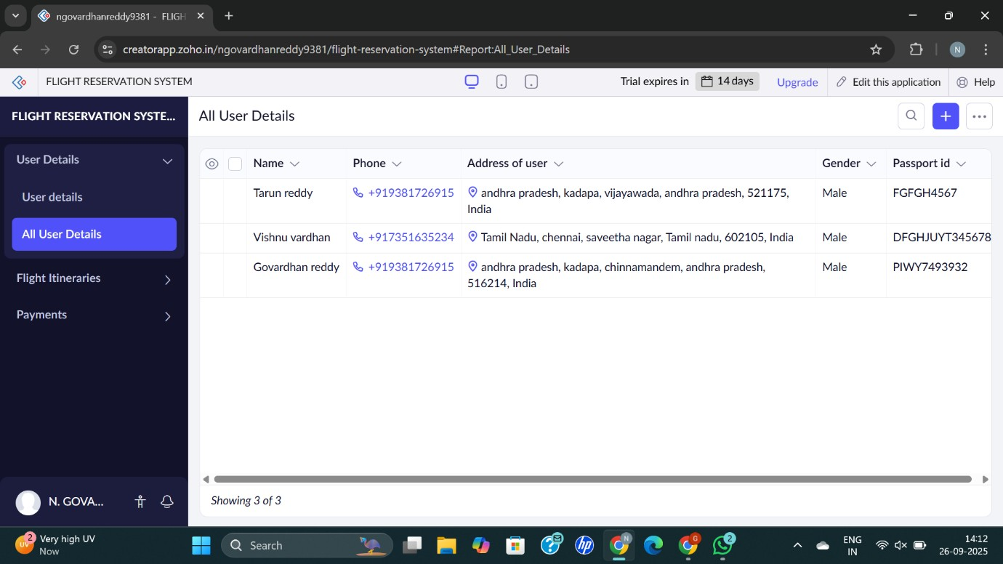

- FLIGHT FORM
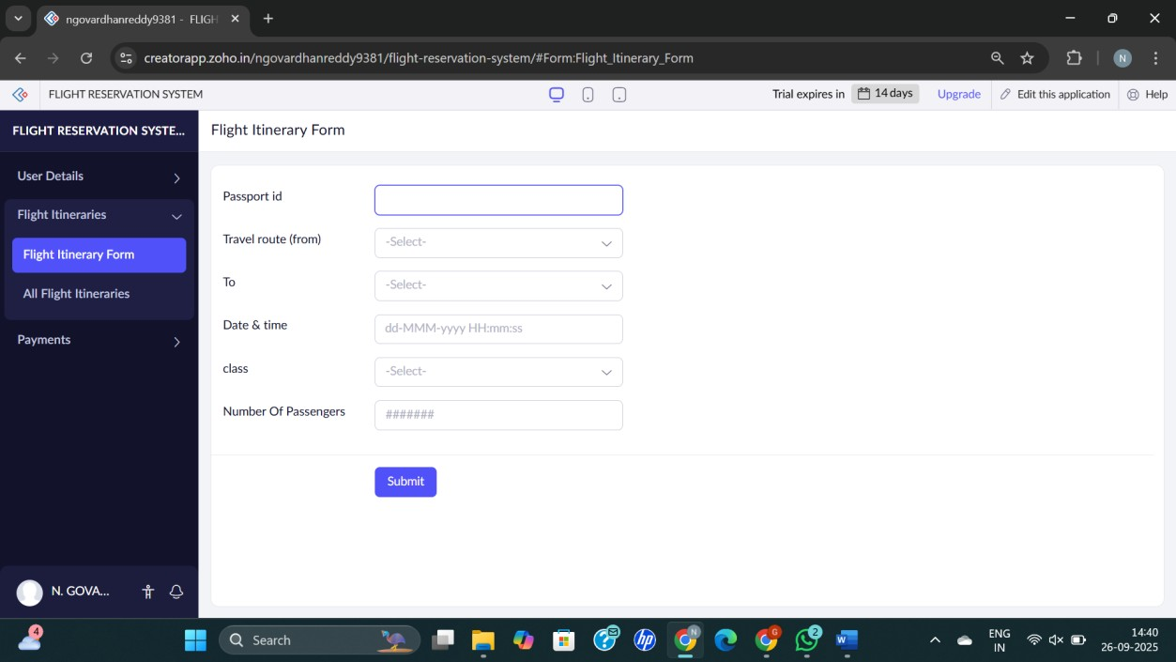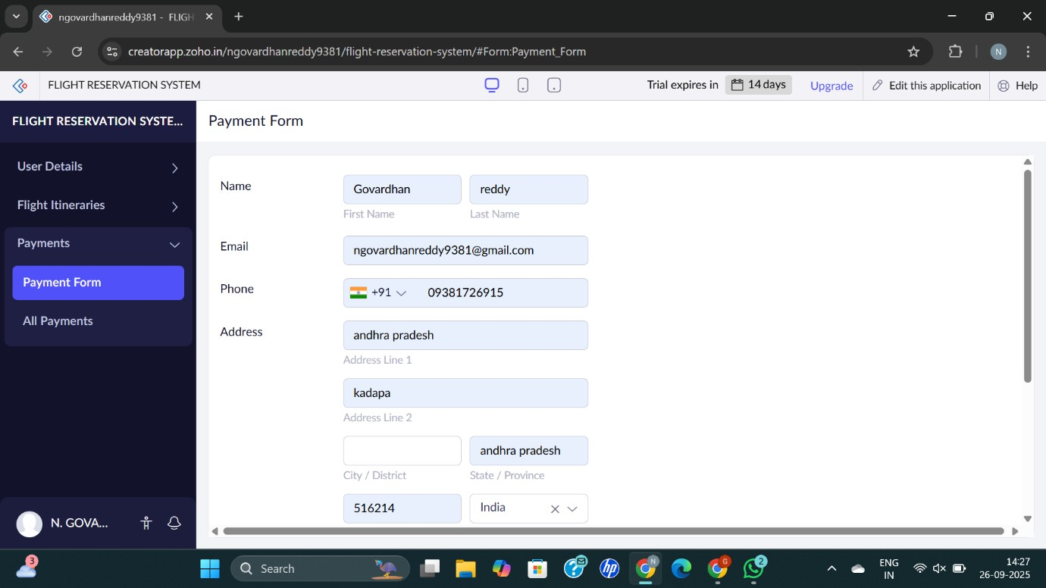

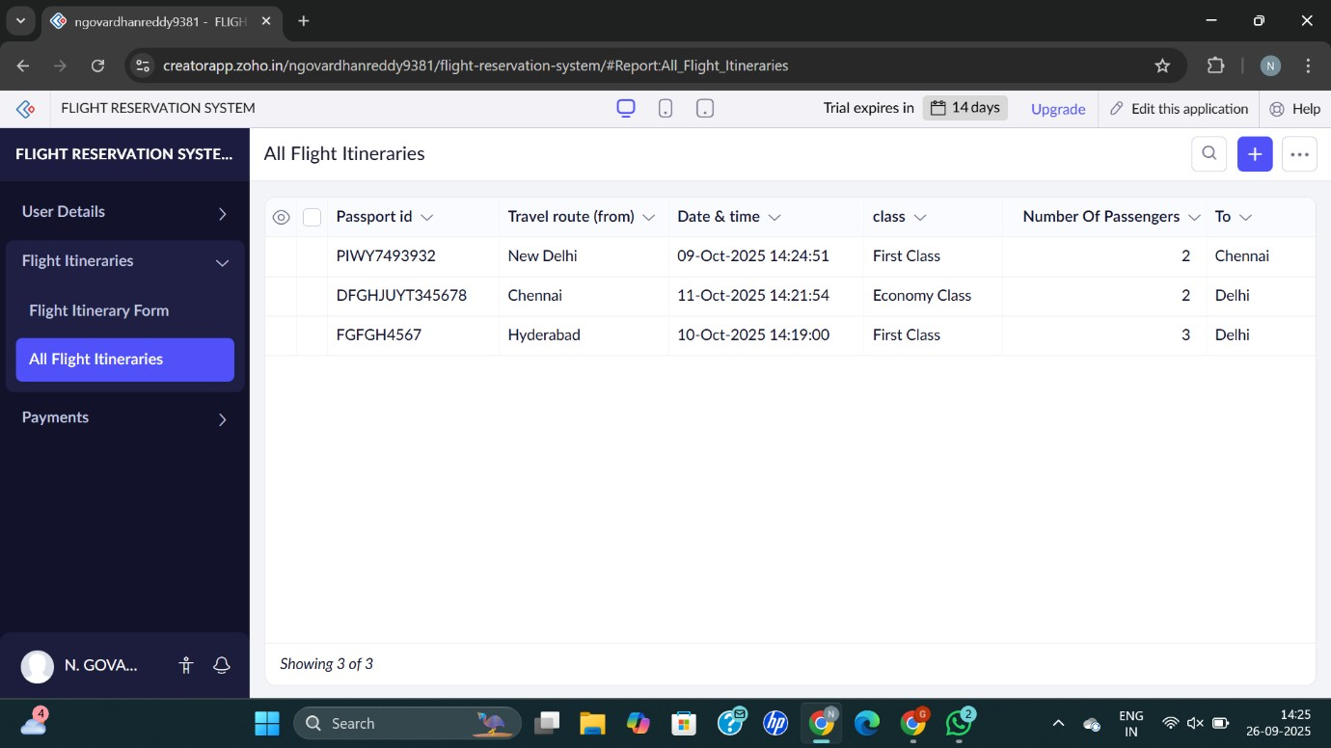

- payment form
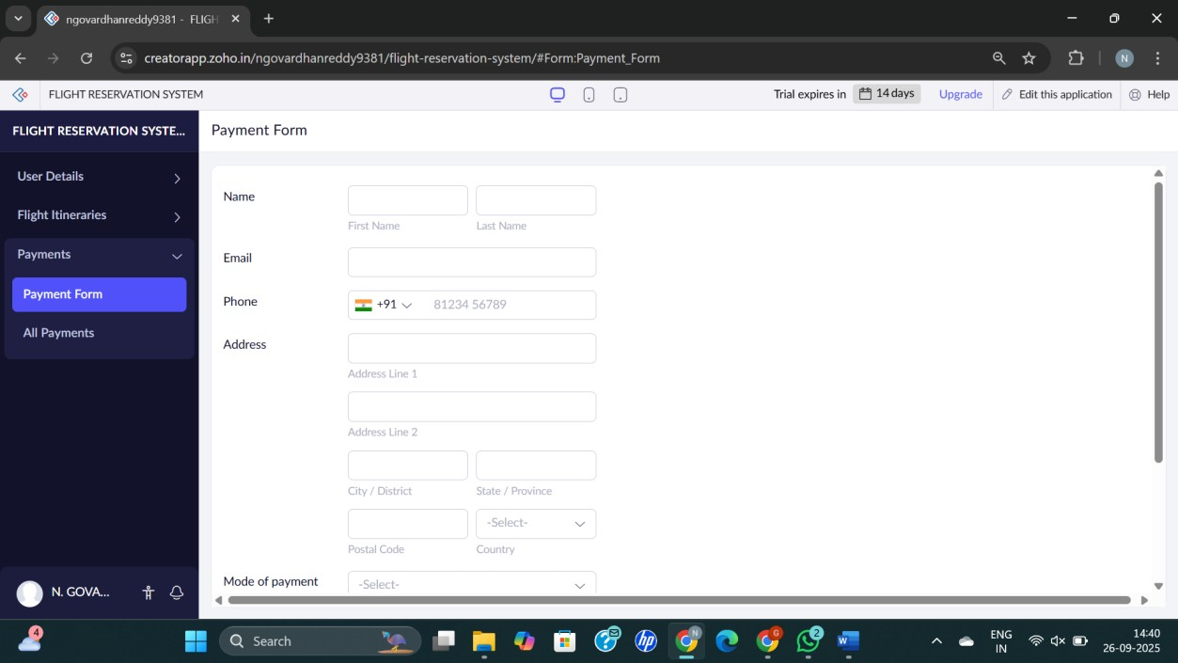


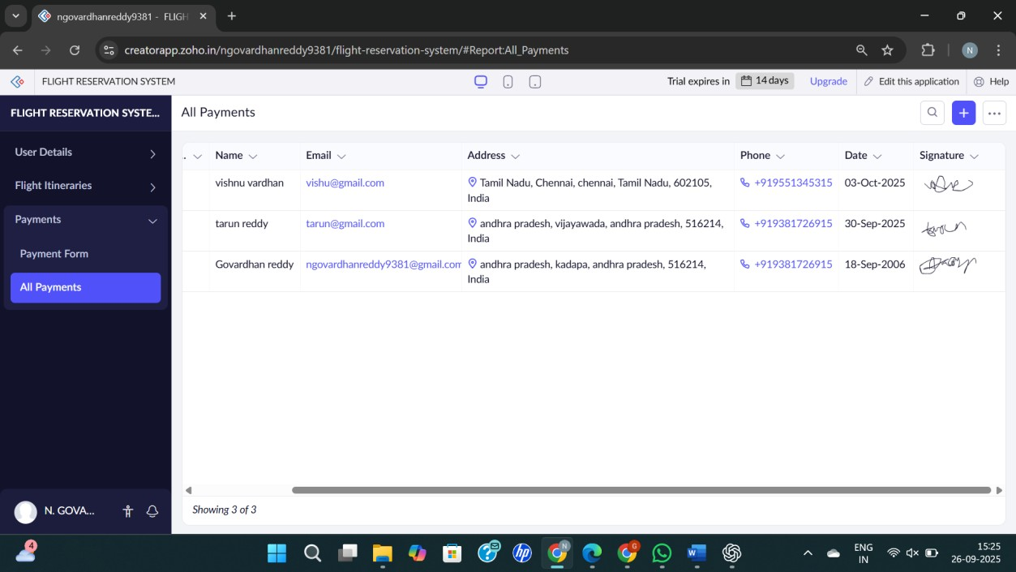

RESULT :
Successfully created a simple cloud software application for flight reservation system using any cloud service provider to demonstrate SaaS.

